By Blake, William

William Blake was born in London and was educated at Henry Pars Drawing School before becoming apprentice to the engraver, James Basire (1772-79). By the time he
opened a print shop in London in 1784, he was already established as a graphic designer and drawing tutor. When he went to live in Sussex (1800-03), he was
charged with high treason but acquitted, after which he returned to London.
After a rather unsuccessful show of his artistic work in 1809, he went into obscurity and became a mystic. A radical supporter of the French Revolution, he was an outright critic of the social evils which he linked with the
Industrial Revolution. His work as a poet and artist is usually understood in the context of his social, political and religious beliefs. He was not really understood by his peers but much has been written on him by twentieth-century readers who appreciate the greatness he achieved in his many fields of interest.

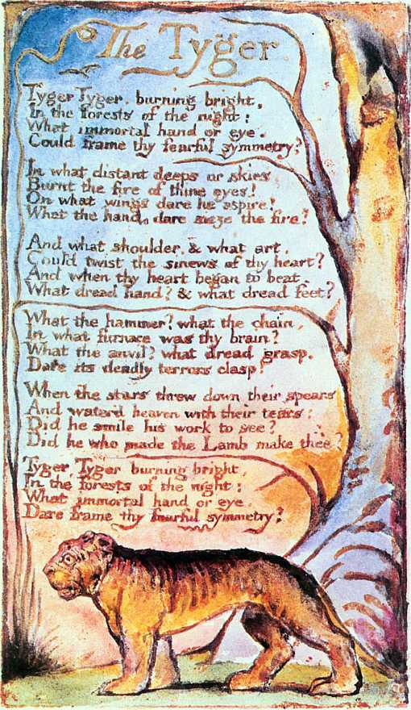

Tiger, The.
By Blake, William .

Tiger! Tiger! burning bright
In the forests of the night,
What immortal hand or eye
Could frame thy fearful symmetry?

In what distant deeps or skies
Burnt the fire of thine eyes?
On what wings dare he aspire?
What the hand dare seize the fire?

And what shoulder, and what art,
Could twist the sinews of thy heart?
And when thy heart began to beat,
What dread hand? and what dread feet?

What the hammer? what the chain?
In what furnace was thy brain?
What the anvil? what dread grasp
Dare its deadly terrors clasp?

When the stars threw down their spears,
And watered heaven with their tears,
Did he smile his work to see?
Did he who made the Lamb make thee?

Tiger! Tiger! burning bright
In the forests of the night,
What immortal hand or eye
Dare frame thy fearful symmetry?

