Lamb, The.
By Blake, William

William Blake was born in London and was educated at Henry Pars Drawing School before becoming apprentice to the engraver, James Basire (1772-79). By the time he
opened a print shop in London in 1784, he was already established as a graphic designer and drawing tutor. When he went to live in Sussex (1800-03), he was
charged with high treason but acquitted, after which he returned to London.
After a rather unsuccessful show of his artistic work in 1809, he went into obscurity and became a mystic. A radical supporter of the French Revolution, he was an outright critic of the social evils which he linked with the
Industrial Revolution. His work as a poet and artist is usually understood in the context of his social, political and religious beliefs. He was not really understood by his peers but much has been written on him by twentieth-century readers who appreciate the greatness he achieved in his many fields of interest.

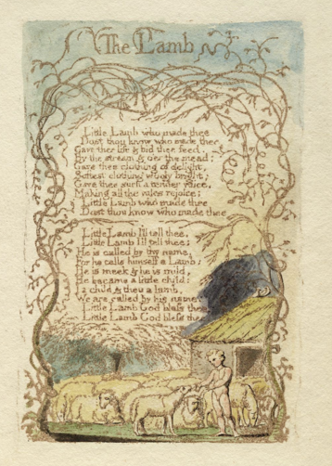

Lamb, The.
By Blake, William .

Little lamb, who made thee?
Dost thou know who made thee?
Gave thee life, and bid thee feed
By the stream and o'er the mead;
Gave thee clothing of delight,
Softest clothing, woolly, bright;
Gave thee such a tender voice,
Making all the vales rejoice?
Little lamb, who made thee?
Dost thou know who made thee?

Little lamb, I'll tell thee,
Little lamb, I'll tell thee:
He is called by thy name,
For He calls Himself a Lamb.
He is meek, and He is mild;
He became a little child.
I a child, and thou a lamb,
We are called by His name.
Little lamb, God bless thee!
Little lamb, God bless thee!

