George Washington Farewell Address

On February 22, 1732, George Washington is born in Westmoreland County,Virginia, the first of six children of Augustine and Mary Ball Washington. (Augustine had three additional children from his first marriage.) An initially loyal British subject, Washington eventually led the Continental Army in theAmerican Revolution and became the new nation's first president. He is often referred to as the father of the United States.
In 1796, as he neared the end of his second term, President George Washington was 64 years old and suffering from ills both physical and political. Plagued by painful dentures and rheumatism, and facing increasing attacks from opponents of his policies, the former Revolutionary War general decided he would not seek a third term in the nation’s highest office.
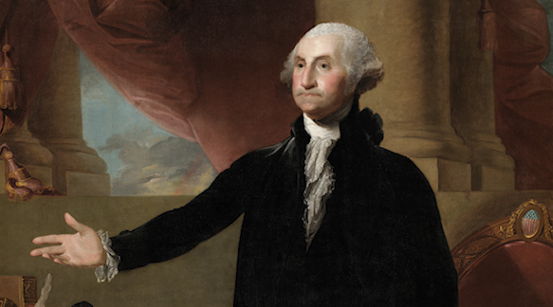
As he did so, he and his longtime friend and protégé, Alexander Hamilton, drafted a farewell address. In the 7,641-word document, the nation’s first president called for the American people to remain unified, resist the rise of political factions and avoid the influence of foreign powers.
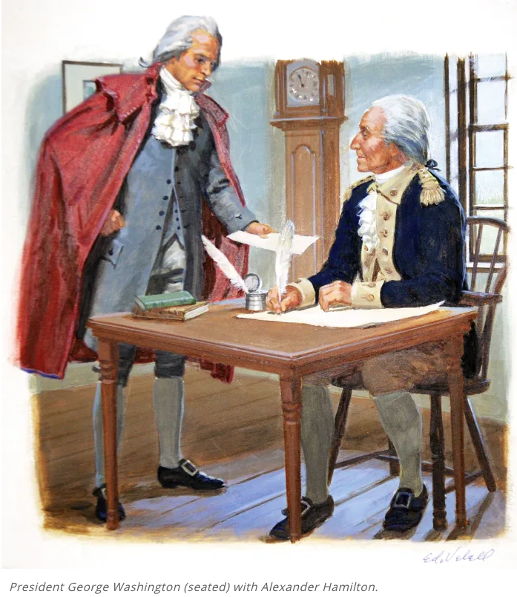Washington was not bound by a two-term limit. But if he died in office, he feared it would establish a precedent that the presidency was a lifetime appointment. Instead, he stepped aside to make way for a successor, proving to future generations (and his contemporary critics) his commitment to democracy rather than power.

WASHINGTON'S FAREWELL ADDRESS, 1796

By George Washington
19th September 1796

Friends and Fellow Citizens: The period for a new election of a citizen, to administer the executive government of the United
States, being not far distant, and the time actually arrived, when your thoughts must be employed in designating the person who is to be clothed with that important trust, it appears to me proper, especially as it may conduce to a more distinct expression of the public voice, that I should now apprise you of the resolution I have formed to decline being considered among the number of those out of whom a choice is to be made.


I rejoice that the state of your concerns, external as well as internal, no longer renders the pursuit of inclination incompatible with the sentiment of duty or propriety; and am persuaded, whatever partiality may be retained for my services, that, in the present circumstances of our country, you will not disapprove my determination to retire.

The impressions, with which I first undertook the arduous trust, were explained on the proper occasion. In the discharge of this trust, I will only say, that I have, with good intentions, contributed toward the organization and administration of the
Government, the best exertions of which a very fallible judgement was capable. Not unconscious, in the outset, of the inferiority of my qualifications, experience in my own eyes, perhaps still more in the eyes of others, has strengthened the motives to diffidence of myself; and every day the increasing weight of years admonishes me more and more, that the shade of retirement is as necessary to me as it will be welcome. Satisfied that if any circumstances have given peculiar value to my services, they were temporary, I have the consolation to believe, that while choice and prudence invite me to quit the political scene, patriotism does not forbid it.

Here, perhaps, I ought to stop. But a solicitude for your welfare, which cannot end but with my life, and the apprehension of danger, natural to that solicitude urge me on an occasion like the present, to offer to your solemn contemplation, and to recommend to your frequent review, some sentiments; which are the result of much reflection, of no inconsiderable observation, and which appear to me all important to the permanency of your felicity as a people. These will be offered to you with the more freedom, as you can only see in them the disinterested warnings of a parting friend, who can possibly have no personal motive as his counsel.

Interwoven as is the love of liberty with every ligament of your hearts, no recommendation of mine is necessary to fortify or confirm the attachment.

The unity of government which constitutes you one people is also now dear to you. It is justly so; for it is a main pillar in the edifice of your real independence, the support of your tranquility at home; your peace abroad; of your safety; of your prosperity; of that very liberty which you so highly prize. But as it is easy to foresee, that from different causes and from different quarters, much pains will be taken, many artifices employed, to weaken in your minds the conviction of this truth; as this is the point in your political fortress against which the batteries of internal and external enemies will be most constantly and actively (though often covertly and insidiously) directed, it is of infinite moment, that you should properly estimate the immense value of your national Union to your collective and individual happiness; that you should cherish a cordial, habitual and immoveable attachment to it; accustoming yourselves to think and speak of it as the palladium of your political safety and prosperity; watching for its preservation with jealous anxiety; discountenancing whatever may suggest even a suspicion that it can in any event be abandoned, and indignantly frowning upon the first dawning of every attempt to alienate any portion of our country from the rest, or to enfeeble the sacred ties which now link together the various parts.

For this you have every inducement of sympathy and interest. Citizens by birth or choice, of a common country, that country has a right to concentrate your affections. The name of 'American', which belongs to you, in your national capacity, must always exalt the just pride of patriotism, more than any appellation derived from local discriminations. With slight shades of difference, you have the same religion, manners, habits and political principles. You have in a common cause fought and triumphed together. The independence and liberty you possess are the work of joint councils, and joint efforts; of common dangers, sufferings and successes.

But these considerations, however powerfully they address themselves to your sensibility, are greatly outweighed by those which apply more immediately to your interest. Here every portion of our country finds the most commanding motives for carefully guarding and preserving the union of the whole.

The North, in an unrestrained intercourse with the South, protected by the equal laws of a common Government, finds in the production of the latter, great additional resources of maritime and commercial enterprise and precious materials of manufacturing industry. The South in the same intercourse, benefiting by the agency of the North, sees its agriculture grow and its commerce expand. Turning partly into its own channels the seamen of the North, it finds its particular navigation envigorated; and while it contributes, in different ways, to nourish and increase the general mass of the national navigation, it looks forward to the protection of a maritime strength, to which itself is unequally adapted. The East, in a like intercourse with the West, already finds, and in the progressive improvement of interior communications, by land and water, will more and more find a valuable vent for the commodities which it brings from abroad, or manufactures at home. The West derives from the East supplies requisite to its growth and comfort, and what is perhaps of still greater consequence, it must of necessity owe the secure enjoyment of indispensable outlets for its own productions to the weight, influence, and the future maritime strength of the Atlantic side of the Union, directed by an indissoluble community of interest as one nation. Any other tenure by which the West can hold this essential advantage, whether derived from its own separate strength, or from an apostate and unnatural connection with any foreign power, must be intrinsically precarious.

While then every part of our country thus feels an immediate and particular interest in union, all the parts combined cannot fail to find in the united mass of means and efforts greater strength, greater resource, proportionably greater security from external danger, a less frequent interruption of their peace by foreign nations; and, what is of inestimable value, they must derive from union an exemption from those broils and wars between themselves, which so frequently afflict neighboring countries, not tied together by the same government; which their own rivalships alone would be sufficient to produce, but which opposite foreign alliances, attachments and intrigues would stimulate and imbitter. Hence, likewise, they will avoid the necessity of those overgrown military establishments which, under any form of government, are inauspicious to liberty and which are to be regarded as particularly hostile to republican liberty. In this sense it is that your union ought to be considered as a main prop of your liberty, and that the love of the one ought to endear you to the preservation of the other.

Is there a doubt whether a common government can embrace so large a sphere? Let experience solve it. To listen to mere speculation in such a case were criminal. It is well worth a fair and full experiment. With such powerful and obvious motives to union affecting all parts of our country, while experience shall not have demonstrated its impracticability, there will always be reason to distrust the patriotism of those who in any quarter may endeavor to weaken its bands.

In contemplating the causes which may disturb our union, it occurs as a matter of serious concern, that any ground should have been furnished for characterizing parties by geographical discriminations: Northern and Southern; Atlantic and Western; whence designing men may endeavor to excite a belief that there is a real difference of local interests and views. One of the expedients of party to acquire influence, within particular districts, is to misrepresent the opinions and aims of other districts. You cannot shield yourselves too much against the jealousies and heart burnings which spring from these misrepresentations; they tend to render alien to each other those who ought to be bound together by fraternal affection.

To the efficacy and permanency of your union, a Government for the whole is indispensable. No alliances however strict between the parts can be an adequate substitute. They must inevitably experience the infractions and interruptions which all alliances in all times have experienced. Sensible of this momentous truth, you have improved upon your first essay, by the adoption of a Constitution of Government, better calculated than your former for an intimate union, and for the efficacious management of your common concerns. This Government, the offspring of your own choice uninfluenced and unawed, adopted upon full investigation and mature deliberation, completely free in its principles, in the distribution of its powers, uniting security with energy, and containing within itself a provision for its own amendment, has a just claim to your confidence and your support. Respect for its authority, compliance with its laws, acquiescence in its measures, are duties enjoined by the fundamental maxims of true liberty. The basis of our political systems is the right of the people to make and to alter their constitutions of government. But the constitution which at any time exists till changed by an explicit and authentic act of the whole people is sacredly obligatory upon all. The very idea of the power and the right of the people to establish government presupposes the duty of every individual to obey the established government.

Toward the preservation of your government and the permanency of your present happy state, it is requisite not only that you steadily discountenance irregular oppositions to its acknowledged authority, but also that you resist with care the spirit of innovation upon its principles, however specious the pretexts. One method of assault may be to effect in the forms of the
Constitution alterations which will impair the energy of the system, and thus to undermine what cannot be directly overthrown. In all the changes to which you may be invited remember that time and habit are at least as necessary to fix the true character of governments as of other human institutions; that experience is the surest standard by which to test the real tendency of the existing constitution of a country; that facility in changes upon the crdit of mere hypothesis and opinion exposes to perpetual change, from the endless variety of hypothesis and opinion; and remember especially that for the efficient management of your common interests in a country so extensive as ours a government of as much vigor as is consistent with the perfect security of liberty is indispensable. Liberty itself will find in such a government, with powers properly distributed and adjusted, its surest guardian. It is, indeed, little else than a name where the government is too feeble to withstand the enterprises of faction, to confine each member of the society within the limits prescribed by the laws, and to maintain all in the secure and tranquil enjoyment of the rights of person and property.

I have already intimated to you the danger of parties in the State, with particular reference to the founding of them on geographical discriminations. Let me now take a more comprehensive view, and warn you in the most solemn manner against the baneful effects of the spirit of party generally.

This spirit, unfortunately, is inseparable from our nature, having its root in the strongest passions of the human mind. It exists under different shapes in all governments, more or less stifled, controlled, or repressed; but in those of the popular form it is seen in its greatest rankness and is truly their worst enemy.

It serves always to distract the public councils and enfeeble the public administration. It agitates the community with illfounded jealousies and false alarms; kindles the animosity of one part against another; foments occasionally riot and insurrection. It opens the door to foreign influence and corruption, which find a facilitated access to the government itself through the channels of party passion. Thus the policy and the will of one country are subjected to the policy and will of another.

There is an opinion that parties in free countries are useful checks upon the administration of government, and serve to keep alive the spirit of liberty. This within certain limits is probably true; and in governments of a monarchial cast patriotism may look with indulgence, if not with favor, upon the spirit of party. But in those of the popular character, in governments purely elective, it is a spirit not to be encouraged. From their natural tendency it is certain there will always be enough of that spirit for every salutary purpose; and there being constant danger of excess, the effort ought to be by force of public opinion to mitigate and assuage it. A fire not to be quenched, it demands a uniform vigilance to prevent its bursting into a flame, lest, instead of warming, it should consume.

It is important, likewise, that the habits of thinking in a free country should inspire caution in those intrusted with its administration to confine themselves within their respective constitutional spheres, avoiding in the exercise of the powers of one department to encroach upon another. The spirit of encroachment tends to consolidate the powers of all the departments in one, and thus to create, whatever the form of government, a real despotism.

If in the opinion of the people the distribution or modification of the constitutional powers be in any particular wrong, let it be corrected by an amendment in the way which the Constitution designates. But let there be no change by usurpation; for though this in one instance may be the instrument of good, it is the customary weapon by which free governments are destroyed. The precedent must always greatly overbalance in permanent evil any partial or transient benefit which the use can at any time yield.

Of all the dispositions and habits which lead to political prosperity, religion and morality are indispensable supports. In vain would that man claim the tribute of patriotism who should labor to subvert these great pillars of human happiness - these firmest props of the duties of men and citizens. The mere politician, equally with the pious man, ought to respect and to cherish them. A volume could not trace all their connections with private and public felicity. Let it simply be asked, Where is the security for property, for reputation, for life, if the sense of religious obligation desert the oaths which are the instruments of investigation in courts of justice? And let us with caution indulge the supposition that morality can be maintained without religion. Whatever may be conceded to the influence of refined education on minds of peculiar structure, reason and experience both forbid us to expect that national morality can prevail in exclusion of religious principle.

It is substantially true that virtue or morality is a necessary spring of popular government. The rule indeed extends with more or less force to every species of free government. Who that is a sincere friend to it can look with indifference upon attempts to shake the foundation of the fabric? Promote, then, as an object of primary importance, institutions for the general diffusion of knowledge. In proportion as the structure of a government gives force to public opinion, it is essential that public opinion should be enlightened.

As a very important source of strength and security, cherish public credit. One method of preserving it is to use it as sparingly as possible, avoiding occasions of expense by cultivating peace, but remembering also that timely disbursements to prepare for danger frequently prevent much greater disbursements to repel it; avoiding likewise the accumulation of debt, not only by shunning occasions of expense, but by exertions in time of peace to discharge the debts which unavoidable wars have occasioned, not ungenerously throwing upon posterity the burthen which we ourselves ought to bear.

Observe good faith and justice toward all nations. Cultivate peace and harmony with all. Religion and morality enjoin this conduct. And can it be that good policy does not equally enjoin it? It will be worthy of a free, enlightened, and at no distant period a great nation to give to mankind the magnanimous and too novel example of a people always guided by an exalted justice and benevolence. Who can doubt that in the course of time and things the fruits of such a plan would richly repay any temporary advantage which might be lost by a steady adherence to it? Can it be that Providence has not connected the permanent felicity of a nation with its virtue? The experiment, at least, is recommended by every sentiment which enobles human nature. Alas! is it rendered impossible by its vices?

In the execution of such a plan nothing is more essential than that permanent, inveterate antipathies against particular nations and passionate attachments for others should be excluded, and that in place of them just and amicable feelings toward all should be cultivated. The nation which indulges toward another an habitual hatred or an habitual fondness is in some degree a slave. It is a slave to its animosity or to its affection, either of which is sufficient to lead it astray from its duty and its interest. Antipathy in one nation against another disposes each more readily to offer insult and injury, to lay hold of slight causes of umbrage, and to be haughty and intractable when accidental or trifling occasions of dispute occur.

So, likewise, a passionate attachment of one nation for another produces a variety of evils. Sympathy for the favorite nation, facilitating the illusion of an imaginary common interest in cases where no real common interest exists, and infusing into one the enmities of the other, betrays the former into a participation in the quarrles and wars of the latter without adequate inducement or justification. It leads also to concessions to the favorite nation of privileges denied to others, which is apt doubly to injure the nation making the concessions by unnecessarily parting with what ought to have been retained, and by exciting jealousy, ill will, and a disposition to retaliate in the parties from whom equal privileges are withheld; and it gives to ambitious, corrupted, or deluded citizens (who devote themselves to the favorite nation) facility to betray or sacrifice the interests of their own country without odium, sometimes even with popularity, gilding with the appearances of a virtuous sense of obligation, a commendable deference for public opinion, or a laudable zeal for public good the base or foolish compliances of ambition, corruption, or infatuation.

Against the insidious wiles of foreign influence (I conjure you to believe me, fellow citizens) the jealousy of a free people ought to be constantly awake, since history and experience prove that foreign influence is one of the most baneful foes of republican government. But that jealousy, to be useful, must be impartial, else it becomes the instrument of the very influence to be avoided, instead of a defense against it. Excessive partiality for one foreign nation and excessive dislike of another cause those whom they actuate to see danger only on one side, and serve to veil and even second the arts of influence on the other. Real patriots who may resist the intrigues of the favorite are liable to become suspected and odious, while its tools and dupes usurp the applause and confidence of the people to surrender their interests.

The great rule of conduct for us in regard to foreign nations is, in extending our commercial relations to have with them as little political connection as possible. So far as we have already formed engagements let them be fulfilled with perfect good faith. Here let us stop.

Europe has a set of primary interests which to us have none or a very remote relation. Hence she must be engaged in frequent controversies, the causes of which are essentially foreign to our concerns. Hence, therefore, it must be unwise in us to implicate ourselves by artificial ties in the ordinary vicissitudes of her politics or the ordinary combinations and collisions of her friendships or enmities.

Our detached and distant situation invites and enables us to pursue a different course. If we remain one people, under an efficient government, the period is not far off when we may defy material injury from external annoyance; when we may take such an attitude as will cause the neutrality we may at any time resolve upon to be scrupulously respected; when beligerent nations, under the impossibility of making acquisitions upon us, will not lightly hazard the giving us provocation; when we may choose peace or war, as our interest, guided by justice, shall counsel.

Why forego the advantages of so peculiar a situation? Why quit our own to stand upon foreign ground? Why, by interweaving our destiny with that of any part of Europe, entangle our peace and prosperity in the toils of European ambition, rivalship, interest, humor, or caprice?

It is our true policy to steer clear of permanent alliances with any portion of the foreign world, so far, I mean, as we are now at liberty to do it; for let me not be understood as capable of patronizing infidelity to existing engagements. I hold the maxim no less applicable to public than to private affairs that honesty is always the best policy. I repeat, therefore, let those engagements be observed in their genuine sense. But in my opinion it is unnecessary and would be unwise to extend them.

Taking care always to keep ourselves by suitable establishments on a respectable defensive posture, we may safely trust to temporary alliances for extraordinary emergencies.

Harmony, liberal intercourse with all nations are recommended by policy, humanity, and interest. But even our commercial policy should hold an equal and impartial hand, neither seeking nor granting exclusive favors or preferences; consulting the natural course of things; diffusing and diversifying by gentle means the streams of commerce, but forcing nothing; establishing with powers so disposed, in order to give trade a stable course, to define the rights of our merchants, and to enable the
Government to support them, conventional rules of intercourse, the best that present circumstances and mutual opinion will permit, but temporary and liable to be from time to time abandoned or varied as experience and circumstances shall dictate; constantly keeping in view that it is folly in one nation to look for disinterested favors from another; that it must pay with a portion of its independence for whatever it may accept under that character; that by such acceptance it may place itself in the condition of having given equivalents for nominal favors, and yet being reproached with ingratitude for not giving more. There can be no greater error than to expect or calculate upon real favors from nation to nation. It is an illusion which experience must cure, which a just pride ought to discard.

Though in reviewing the incidents of my Administration I am unconscious of intentional error, I am nevertheless too sensible of my defects not to think it probable that I may have committed many errors. Whatever they may be, I fervently beseech the Almighty to avert or mitigate the evils to which they may tend. I shall also carry with me the hope that my country will never cease to view them with indulgence, and that, after forty-five years of my life dedicated to its service with an upright zeal, the faults of incompetent abilities will be consigned to oblivion, as myself must soon be to the mansions of rest.

Relying on its kindness in this as in other things, and actuated by that fervent love toward it which is so natural to a man who views in it the native soil of himself and his progenitors for several generations, I anticipate with pleasing expectation that retreat in which I promise myself to realize without alloy the sweet enjoyment of partaking in the midst of my fellow-citizens the benign influence of good laws under a free government - the ever-favorite object of my heart, and the happy reward, as I trust, of our mutual cares, labors and dangers.

George Washington.

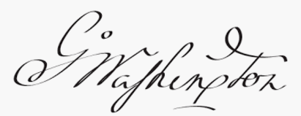
-------------------------------------

Prepared by Gerald Murphy (The Cleveland Free-Net - aa300)
Distributed by the Cybercasting Services Division of the
National Public Telecomputing Network (NPTN).

Permission is hereby granted to download, reprint, and/or otherwise
redistribute this file, provided appropriate point of origin
credit is given to the preparer(s) and the National Public
Telecomputing Network.

