English Worksheet


Items highlighted in yellow are tasks for you to complete
Items in Blue italics are help tips

Inserting Symbol (Word)

Type out the keys
Qwertyuiop[]asdfghjkl;’zxcvbnm,./

Insert Symbol
Æ
¥∑π∏∫Ω√∆‰

Insert an equation
1. Click where you want to insert the equation.
2. On the Insert menu, click Object.
3. In the Object type box, click Microsoft Equation.
4. Click OK. Or close Equation box
5. Build the equation by selecting symbols from the Equation toolbar and typing variables and numbers. From the top row of the Equation toolbar, you can choose from more than 150 mathematical symbols. From the bottom row, you can choose from a variety of templates or frameworks that contain symbols such as fractions, integrals, and summations.
For Help on creating an equation, click Equation Editor Help on the Equation Editor Help men6. When you are finished creating your equation, click Quit Equation Editor on the Equation Editor menu

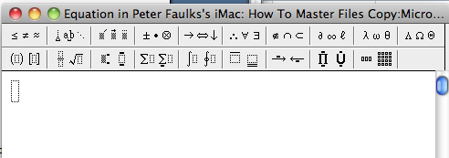

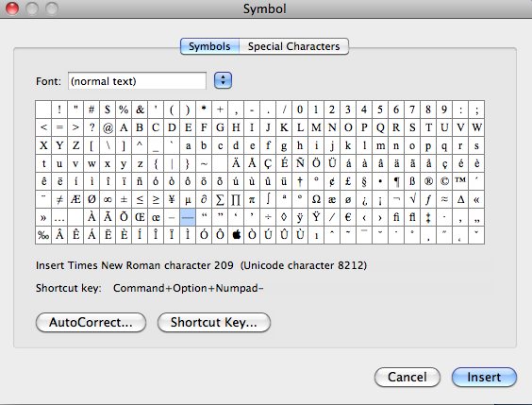

Qwerty set 1
q | w | e | r | t | y | u | I | o | p | [ | ]
a | s | d | f | g | h | j | k | l | ; | ’
z | x | c | v | b | n | m | , | . | /
1 | 2 | 3 | 4 | 5 | 6 | 7 | 8 | 9 | 0 | - | =

Shift Key
Q | W | E | R | T | Y | U | I | O | P | [ | ]
A | S | D | F | G | H | J | K | L | ; | ’
Z | X | C | V | B | N | M | , | . | /
! | @ | # | $ | % | ^ | & | * | ( | ) | _ | +

Using alt key
Q | W | E | R | T | Y | U | I | O | P | [ | ]
œ | ∑ |  | ® | † | ¥ |  |  | ø | π | “ | ‘
A | S | D | F | G | H | J | K | L | ; | ’
å | ß | ∂ | ƒ | © | ˙ | ∆ | ˚ | ˚ | … | æ
Z | X | C | V | B | N | M | , | . | /
Ω | ≈ | ç | √ | ∫ |  | ˜µ | ≤ | ≥ | ÷
1 | 2 | 3 | 4 | 5 | 6 | 7 | 8 | 9 | 0 | - | =
¡ | ™ | £ | ¢ | ∞ | § | ¶ | • | ª | º | – | ≠

Using shift+alt key
Q | W | E | R | T | Y | U | I | O | P | [ | ]
Œ | Á | ´ | ‰ | ˇ | Á | ¨ | ˆ | Ø | ∏ | ” | ’
A | S | D | F | G | H | J | K | L | ; | ’
Å | Í | Î | Ï | ˝ | Ó | Ô |  | Ò | Ú | Æ
Z | X | C | V | B | N | M | , | . | /
¸ | ˛ | Ç | ◊ | ı | ˜ | Â | ¯ | ˘ | ¿
1 | 2 | 3 | 4 | 5 | 6 | 7 | 8 | 9 | 0 | - | =
⁄ | € | ‹ | › | ﬁ | ﬂ | ‡ | ° | · | Ø

Insert Symbol

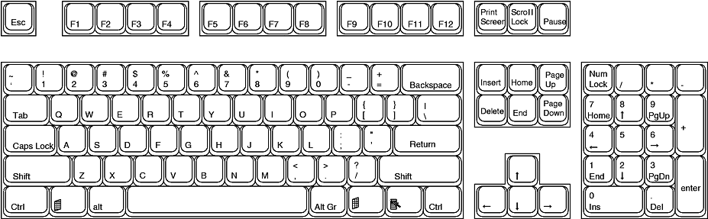
Keyboard Functions

Escape - Esc is used to back out of situations.
F1 - While working in an application, depressing this key will bring up the applications help menu.
If there is no open application F1 will open Windows Help.
F2 - Choose this key to rename a selected item.
F3 - Depressing this key will display the Find: All Files dialog box.
F4 - Holding down the Alt key while depressing F4 closes the current active window. If there is no active window this opens the Shut Down dialog box.
F5 - Select this key to refresh the contents of a dialog box, such as the Save As or Open dialog boxes, or in a window such as a Windows Explorer window.
F6 - F6 + Ctrl to move to a previous window if you have multiple documents open in MS Word
F7 - Perform Spell and Grammar check in MS Word
F10 - Activates Menu Bar options. Use right and left arrows to select menus and down arrows to display pull down menus.
F11 - In Internet Explorer this key will allow you to toggle back and forth between full screen view and normal view
each time you tap F11 in word a new worksheet is added.
F12 - Open a new document in MS Word
Print Screen- This sends a copy of whatever is on the screen to the clipboard.


Need help just ask

