English Worksheet


Items highlighted in yellow are tasks for you to complete
Items in Blue italics are help tips

Using Special Characters (Word)

English Characters

At
Ampersat, asperand, arobase, at, at sign, or at symbol is the name of the " @ " symbol found above the 2 on a U.S. keyboard. When describing an e-mail address, it may be described as "support - at - computerhope - dot - com," which is the same assupport@computerhope.com.

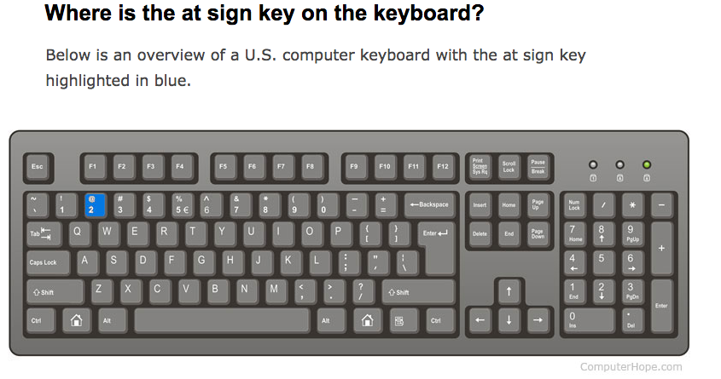How to create the @ symbol

Creating the @ symbol on a U.S. keyboard
To create the at symbol using a U.S. PC keyboard, hold down the Shift key and press the number 2 near the top of the keyboard.
To create the at symbol using an Apple keyboard, hold down the Option key and press the number 2 at the top of the keyboard.

Creating the @ symbol on a smartphone or tablet
To create the at symbol on a smartphone or tablet, open the keyboard, go into the numbers or symbols (sym) section, and tap the @ symbol.

cedilla
a mark (¸) written under the letter c, especially in French, to show that it is pronounced like an s rather than a k (e.g. façade ).

Grave
Alternatively known as acute, backtick, left quote, or an open quote, the back quote or backquote is a punctuation mark (`). It's on the same U.S. computer keyboard key as the tilde.

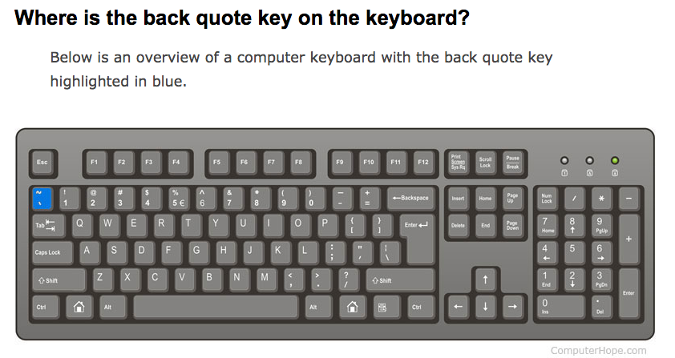

Press “Ctrl" plus the grave accent key and then the letter to insert a grave accent. Press “Ctrl-Shift” and the caret (" ^ ") key and then the letter to insert a circumflex accent. Press “Ctrl-Shift" and the tilde (" ~ ") key and then the letter to insert a tilde accent.

Link https://www.computerhope.com/jargon/b/backquot.htm

What is a tilde is used for on a computer?
Below are a few examples of how and when the tilde is used.
- In languages like Spanish and Portuguese, the tilde is a diacritical mark over letters such as 'ñ' and 'ã' indicating alternate pronunciation of a consonant or vowel.
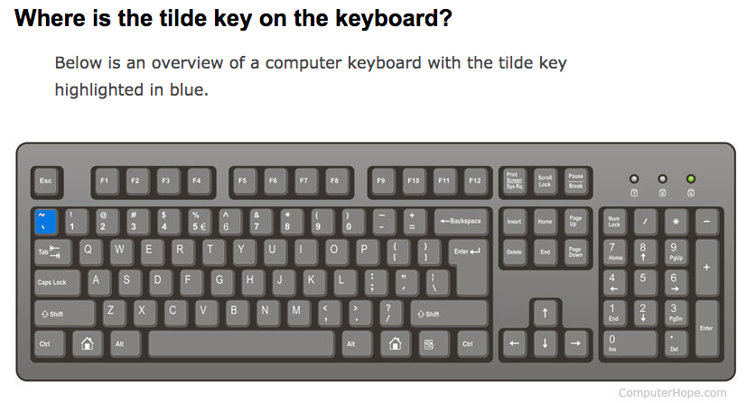
umlaut
a mark (¨) used over a vowel, especially in German, to indicate a different vowel quality.

Special symbols

ä \a" ë \e" ï \i" ö \o" ü \u" ÿ \y" Ä \A" Ë \E" Ï \I" Ö \O" Ü \U" Ÿ \Y"
á \a' ć \c' é \e' í \i' ń \n' ó \o' ś \s' ú \u' ý \y' ź \z' Á \A' Ć \C' É \E' Í \I' Ń \N' Ó \O' Ś \S' Ú \U' Ý \Y' Ź \Z'
ő \o: ű \u: Ő \O: Ű \U:
à \a` è \e` ì \i` ò \o` ù \u` À \A` È \E` Ì \I` Ò \O` Ù \U`
â \a^ ê \e^ î \i^ ô \o^ û \u^ Â \A^ Ê \E^ Î \I^ Ô \O^ Û \U^
ã \a~ ñ \n~ õ \o~ Ã \A~ Ñ \N~ Õ \O~
č \c< ď \d< ě \e< ǧ \g< ň \n< ř \r< š \s< ť \t< ž \z< Č \C< Ď \D< Ě \E< Ǧ \G< Ň \N< Ř \R< Š \S< Ť \T< Ž \Z<
đ \d- Đ \D-
å \ao ů \uo Å \Ao Ů \Uo
ą \a; ę \e; Ą \A; Ę \E;
æ \ae Æ \Ae ø \o/ Ø \O/ ç \c, Ç \C, ł \l/ Ł \L/ ß \ss þ \th ż \z! Ż \Z!
¡ \!d ¿ \?d
€ \eu euro, £ \Lp pound sterling, ¥ \Y= yen, ƒ \fd florin, ¢ \c/ cent
§ \SS section, ¶ \|| pilcrow (paragraph)
© \co copyright, ® \re registered, ™ \tm trademark
ª \a_ feminine ordinal, º \o_ masculine ordinal
« \<< left-pointing guillemet, » \>> right-pointing guillemet

Mathematical symbols
· \.c middle dot, × \xx multiplication, ÷ \:- division, ∕ \/d division slash
° \dg degree, ′ \'p prime (minute), ″ \"p double prime (second)
− \-m minus, – \-- en-dash, ± \+- plus-minus
≤ \<_ less than or equal to, ≥ \>_ greater than or equal to, ≠ \=/ not equal to
¬ \no logical not, ∧ \an logical and, ∨ \or logical or
∀ \At for all, ∃ \Er there exists, ∴ \.3 therefore
∝ \oc proportional to, ≡ \=3 defined as (or congruent modulo), ≈ \~~ approximately equal to
√ \Vr square root
← \<-, → \->, ↔ \<>
⇐ \<=, ⇒ \=>, ⇔ \eq
↑ \^|, ≅ \=~ congruent to, ↓ \_|
∞ \oo infinity, ⊥ \Tt up tack (perpendicular to)
∅ \O| empty set, ∩ \ni intersection, ∪ \uu union, ⊂ \c= subset of, ∈ \e= element of
∂ \dd partial differential
⊗ \ox circled times, ⊕ \o+ circled plus
∑ \su summation, ∫ \in integral

Greek letters
To get ευρηκα, you type \ep\up\ro\et\ka\al.
α \al | Α \Al alpha

β \be | Β \Be beta

γ \ga | Γ \Ga gamma

δ \de | Δ \De delta

ε \ep | Ε \Ep epsilon

ζ \ze | Ζ \Ze zeta

η \et | Η \Et eta

θ \te | Θ \Te theta | ϑ \t2

ι \io | Ι \Io iota

κ \ka | Κ \Ka kappa

λ \la | Λ \La lambda

μ \mu | Μ \Mu mu

ν \nu | Ν \Nu nu

ξ \xi | Ξ \Xi xi

ο \on | Ο \On omicron

π \pi | Π \Pi pi

ρ \ro | Ρ \Ro rho

σ \si | Σ \Si sigma | ς \s2

τ \ta | Τ \Ta tau

υ \up | Υ \Up upsilon

φ \fi | Φ \Fi phi | ϕ \f2

χ \ci | Χ \Ci chi

ψ \ps | Ψ \Ps psi

ω \om | Ω \Om omega | ϖ \o2

Hebrew letters
To get an alef, you type \?+. On Windows, you have to install international support to get the left-to-right order correct.
א \?+ | alef

ב \B+ | bet

ג \G+ | gimel

ד \D+ | dalet

ה \H+ | he

ו \V+ | vav

ז \Z+ | zayin

ח \X+ | het

ט \Y+ | tet

י \J+ | yod

כ \K+ | kaf | ך \K%

ל \L+ | lamed

מ \M+ | mem | ם \M%

נ \N+ | nun | ן \N%

ס \S+ | samekh

ע \9+ | ayin

פ \P+ | pe | ף \P%

צ \C+ | tsadi | ץ \C%

ק \Q+ | qof

ר \R+ | resh

ש \W+ | shin

ת \T+ | tav

אִ \?+\hI | hiriq

אֶ \?+\sE | segol | אֵ \?+\cE | tsere

אָ \?+\qA | qamats | אַ \?+\pA | patah

אֹ \?+\hO | holam

אֻ \?+\qU | qubuts

ּ \dq | dagesh ormaliq
Combinations:
וֹ \vO | vav holam

וּ \sU | shuruq

Phonetic symbols
See Phonetic symbols

Miscellaneous
\ \bs backslash
• \bu bullet
♣ \cl (club), ♦ \di (diamond), ♥ \he (heart), ♠ \sp (spade)
☞ \pf pointing finger, ❀ \f5 flower-five

