YEAR 11 GEOGRAPHY

SEMESTER TWO 2000

Name of Student:____________________________________

Time allowed for this paper:

Reading time before commencing work: 10 minutes

Working time for paper: 2.5 hours

Your Mark
Section A 20 Marks
Section B 20 Marks
Section C
Part (a) 20 Marks
Part (b) 20 Marks
Part (c) 20 Marks
TOTAL MARK | %

INSTRUCTIONS TO CANDIDATES

This paper consists of Section A, B and C.

Section A – Multiple Choice (to be answered on attached multiple choice answer sheet) All questions should be attempted.

Section B - Short Answer (to be completed within the booklet in the spaces provided). All questions should be attempted

Section C – Extended Answers are to be written on lined paper.

ALL answers to Section C are to be written on lined paper. Answer only 1 question from each part and use a new page for each answer. Section C is worth 60 marks.
SECTION A: MULTIPLE CHOICE

Please tick the appropriate box on answer sheet provided

EXAMINE the topographic map extract and aerial photograph on the BROADSHEET.

- The Height of the land in Grid Square 9466 is best represented as being between:

- 120 – 160m Above Sea Level (ASL)
- 140 – 190m ASL
- 150 – 170m ASL
- 160 – 190m ASL
(1 mark)

2. (i) The shortest distance by road between Jim’s Beach (GR 988 852) and the end of the jetty
at Point Murat (GR 095 846) is closest to:

- 9 kilometres
- 13 kilometres
- 17 kilometres
- 21 kilometres
(1 mark)

- How long would it take to travel the distance you chose in Question 2(i) in a vehicle travelling at an average speed of 70km/hr? Show your working out.
(1 mark)

3. The process involving the pulling apart of oceanic tectonic plates, allowing magma to rise up through the crack/gap and form new plate, is known as:

- Subduction
- Sea Floor Spreading
- Continental Drift
- Isostasy
(1 mark)

4. A-Subduction B-Landslide C-Convergence D-Hydration E-Batholith F-Earthquake
G-Volcano H-Soil Creep

Which of these are examples of the gradation process.

- A,E,B
- B,D,H
- G,F,E
- C,H,A
(1 mark)
- Which of the following are ALL examples of chemical weathering:

- Carbonation, Frost Action, Hydration
- Frost Action, Rock Pressure Reduction, Temperature Change
- Hydration, Solution, Oxidation
- Work of Acids, Temperature Change, Carbonation
(1 mark)

- Under which climatic conditions would the effects of chemical weathering be greatest?

- Hot and wet
- Hot and dry
- Cold and wet
- Cold and dry
(1 mark)

EXAMINE THE TOPOGRAPHIC MAP EXTRACT AND AERIAL PHOTOGRAPH ON THE BROADSHEET.

- Which of the following best describes the latitude and longitude of Yardie Creek Dude Ranch (GR 913 765)?

- 114⁰01’E 21⁰53’S
- 21⁰55’S 114⁰05’E
- 21⁰53’S 114⁰01’E
- 114⁰01’S 21⁰55’E
(1 mark)

EXAMINE THE CLIMATE GRAPHS ON THE EXMOUTH BROADSHEET THEN ASNWER QUESTIONS 8 AND 9

- Which of the following best describes the climate of Exmouth?

- Hot, dry summers; warm, dry winters
- Hot, wet summers; cold, wet winters
- Hot, wet summers; warm, wet winters
- Warm, dry summers; cool dry winters
(1 mark)

- Exmouth’s highest monthly temperature range is closest to:

- 23
- 19
- 15
- 11
(1 mark)
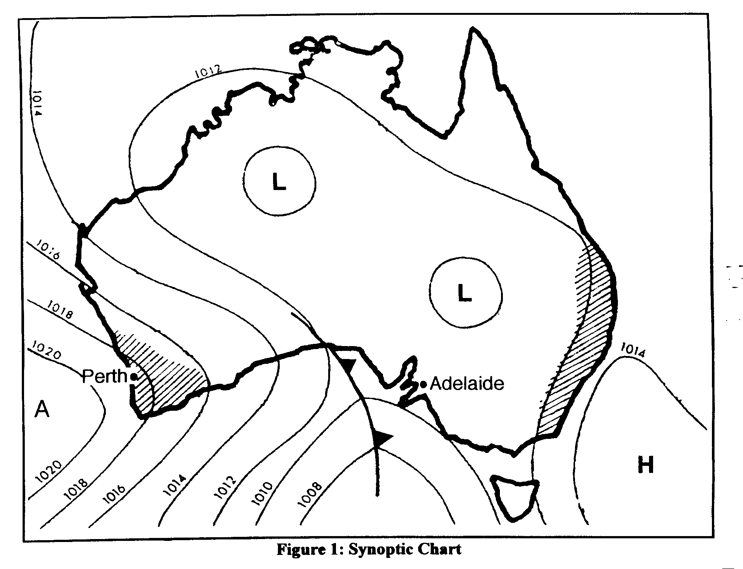
Look at Figure 1.

- What are the TWO terms that could be used to LABEL the pressure system marked “A” on the synoptic chart?

- Cyclone and High
- Anti-cyclone and High
- Anti-cyclone and Low
- Cyclone and Low
(1 mark)

- According to the synoptic chart, the wind direction and air pressure for Perth would be closest to:

- South South East and 10109 hectopascals
- North North West and 1018 hectopascals
- South East and 1017 hectopascals
- South and 1020 hectopascals
(1 mark)

- The process by which all living things combine sugars and O₂ to produce energy, CO₂ and H₂O is known as:

- Respiration
- Digestion
- Decomposition
- Photosynthesis (1 mark)
- Is the map a small, medium or large scale map?
(1 mark)

- Which of the following best describes the latitude and longitude of the Vlaming Head Lighthouse (GR 012 855)?

(a) 114⁰48’E 21⁰06’S
(b) 21⁰48’S 114⁰06’E
(c) 22⁰48’S 114⁰06’E
(d) 114⁰06’S 21⁰48’E
(1 mark)
- The term economic development refers to the:

- Changes in a nation as it becomes less-developed
- Increasing ability of a nation to provide for its people
- Changes in the economy which lead to economic growth
- Process of being declared a developed nation.
(1 mark)

EXAMINE THE TOPOGRAPHIC MAP EXTRACT AND AERIAL PHOTOGRAPH ON THE BROADSHEET

- The total area of the map utilised by the Commonwealth Department of Defence is closest to:

- 10km²
- 40km²
- 100km²
- 20km²
(1 mark)

- Which of the following statements about wind and atmospheric pressure is NOT correct?

- Winds blow in a clockwise direction around a centre of low pressure in the Northern Hemisphere.
- Winds blow in a clockwise direction around a centre of high pressure in the Northern Hemisphere.
- Winds blow in an anti-clockwise direction around a centre of high pressure in the Southern Hemisphere.
- Winds blow in a clockwise direction around a centre of low pressure in the Southern Hemisphere.
(1 mark)

- A cold front occurs when

- a warm air mass overtakes a cold one
- two cold air masses collide
- a cold air mass overtakes a warmer air mass
- none of the above
(1 mark)
19. The Earth experiences seasons because:

- it rotates on its axis
- it revolves around the sun
- its axis is inclined
- of variations in atmospheric density

- both i and ii
- both ii and iv
- both ii and iii
- both iii and iv
(1 mark)

SECTION B: SHORT ANSWER

20. CONSTRUCT a cross-section between GR 970 850 and GR 020 850 using the frame below. ANNOTATE your cross-section by LOCATING and LABELLING these features – intertidal ledge or reef, roads or tracks, and coastline.

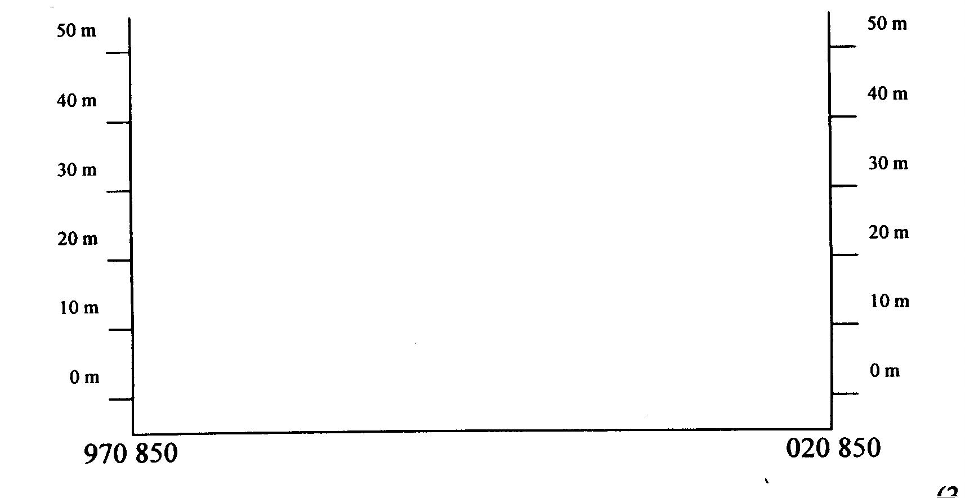
(3 mark)

EXAMINE THE TOPOGRAPHIC MAP EXTRACT AND AERIAL PHOTOGRAPH ON THE BROADSHEET

21. Examine the sketch map in figure 2 below. CONSTRUCT a key that matches the shaded regions with their vegetation characteristics.

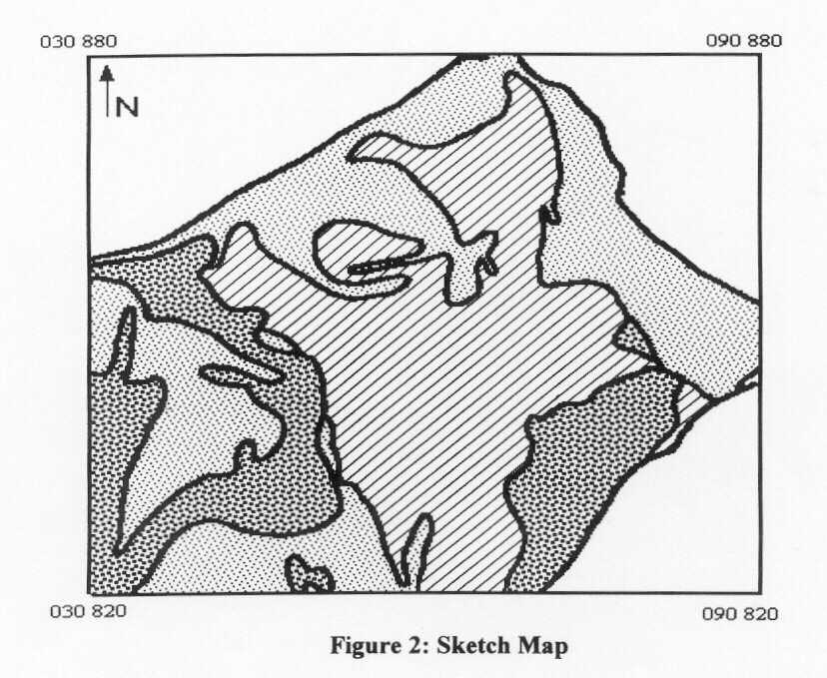

KEY
Shading  Pattern | Vegetation  Characteristics
(3 marks)
- COMPLETE the table below by placing four appropriate indicators of development in the spaces
provided. Note: only ONE is required in each box e.g (Electricity consumption per head of population is low)

 | Social | Economic
Highest in
MDC

Highest in
LDC

(4 marks)

23.

PRIMARY
PRODUCER

SECONDARY
CONSUMER
(CARNIVORE)

Eg:______________ _________________ _______________

Complete the above food chain by:

- placing an appropriate heading in the middle link.
(1 mark)
- placing in each link the name of an organism which would appropriately belong there
(1 ½ marks)
- explain what function is performed by each of these organism

_________________________________________________________________________
_________________________________________________________________________
_________________________________________________________________________
_________________________________________________________________________
_________________________________________________________________________
(2 marks)

- identify the points of energy input and loss within the food chain. Mark these on the diagram.
(1 ½ marks)

24. EXPLAIN how a seabreeze occurs.

________________________________________________________________________________
________________________________________________________________________________
________________________________________________________________________________
________________________________________________________________________________
(4 marks)

SECTION C: EXTENDED ANSWERS

PART a - Climate

Answer EITHER Question C1 or C2

C1. (a) With reference to the main processes involved, DESCRIBE the operation of the
hydrological (water) cycle. Use diagrams/sketches to illustrate your answer.
(8 marks)
- EXPLAIN the term “heat budget”.
(4 marks)

Temperature Change 1960 - 1996
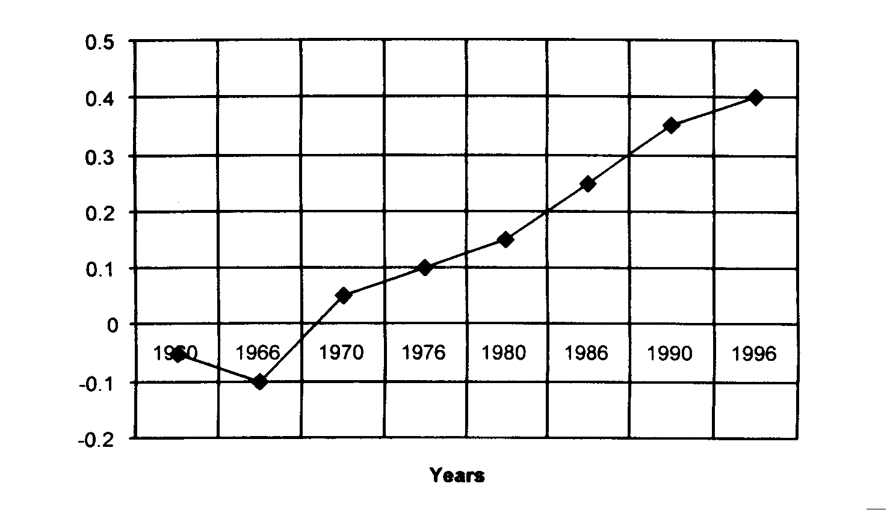

Figure 4: Average Global Temperature Change, 1960 – 1996

- EXAMINE Figure 4 above, then answer the questions that follow.

- OUTLINE the changes in global temperatures since 1960.
(2 marks)

- Using specific examples, DESCRIBE how human activity has contributed to these changes in global temperatures.
(6 marks)

Total = 20 Marks

C2. STUDY Figure 5 below then answer the questions that follow.

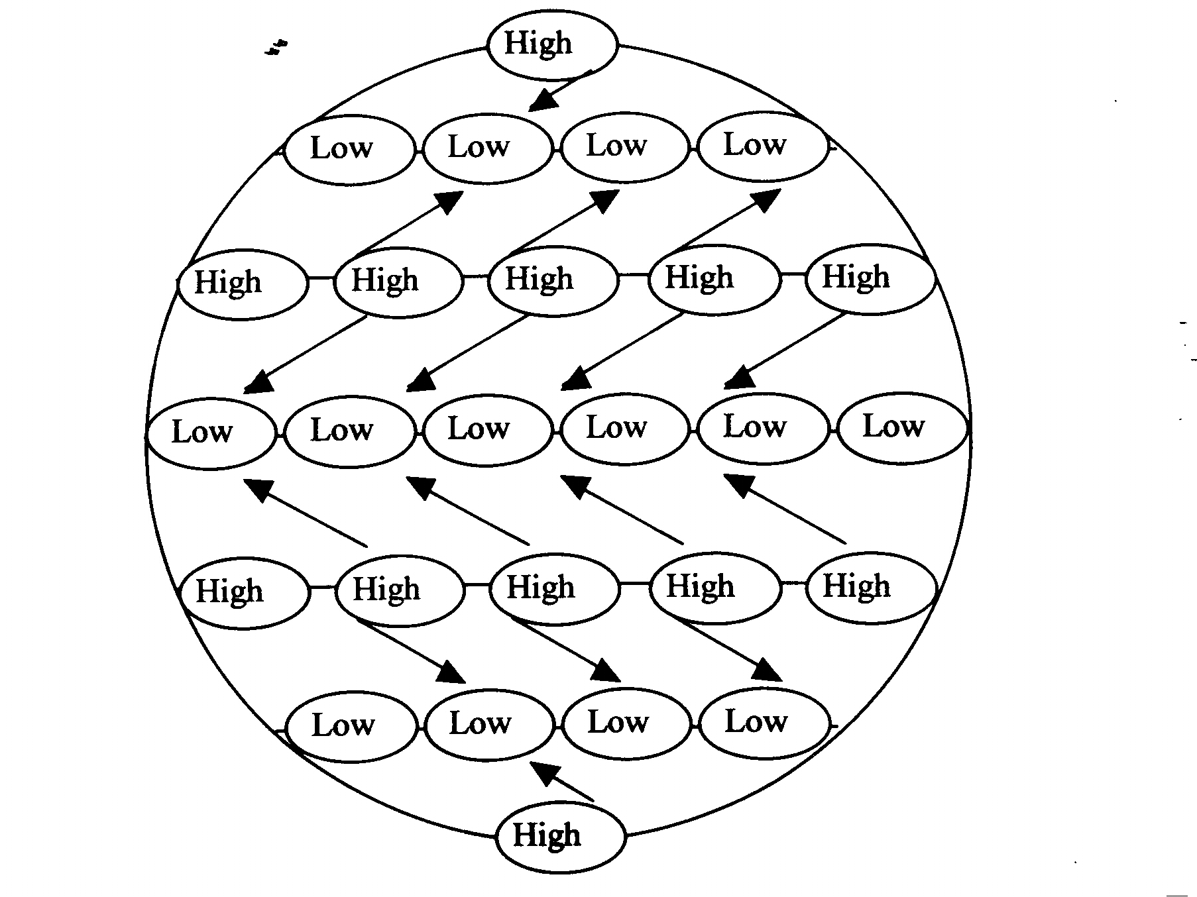

- CONTRAST the characteristics of High AND Low pressure systems.
(2 marks)

- With reference to Figure 5, DESCRIBE and ACCOUNT for the general climatic conditions experienced at the Equator and the Poles.
(8 marks)

- EXPLAIN how TWO factors cause variation in the global pattern of pressure systems. Use diagrams/sketches to illustrate your answer.
(10 marks)

Total = 20 Marks

PART b - Development

Answer EITHER questions C3 or C4

C3. (a) (i) Define the term sustainable development. (2 marks)

(ii) List 2 examples of LDC’s (1 mark)
(iii) List 2 examples of MDC’s (1 mark)

- Explain why these population pyramids of one particular country demonstrates that is has moved from a LDC to a MDC
(2 marks)

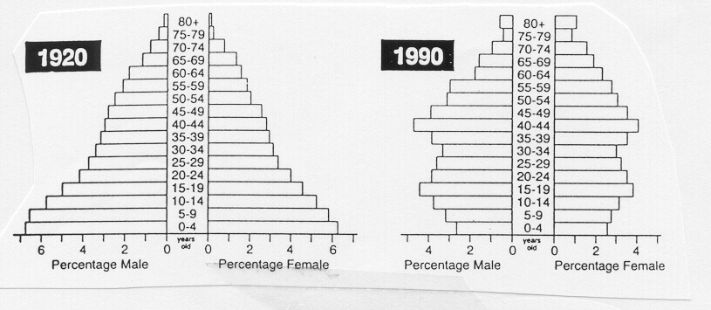

- Rapid population growth has prevented some of the worlds LDC’s from developing over recent years. Below are a number of methods by which a countries population growth can be controlled. Chose four methods from the list and explain their role in reducing population growth.

Care of the Sick & Elderly Debt Reduction
Family Planning Education
Food Distribution Land Reform
Health Care Empowerment of Women
(8 marks)

(d) (i) List the stages in Rostow’s model of Economic development. (2 marks)

(ii) Why can it be argued that this view of the development process is inappropriate in todays society? (4 marks)

Total = 20 Marks

C4. (a) (i) Define Urbanisation. (2 marks)

(ii) Explain why rapid urbanisation has occurred in many LDC’s (4 marks)

(b) (i) With reference to the Table below, explain why the Green Revolution has been seen
as an important weapon in the fight for development in India.

Changes in grain production, yields and the use of fertiliser;
irrigation and high yielding seeds in India, 1950-90
 | 1950-51 | 1990-91
Production (million t)
Rice | 20.6 | 74.6
Wheat | 6.5 | 54.5
Total food grains | 50.8 | 176.2
Yield (kg/ha)
Rice | 668 | 1751
Wheat | 663 | 2274
Total food grains | 522 | 1382

Agricultural inputs
Area under irrigation (millions ha) | 18.0 | 82.8
Area under high yielding seeds  (millions ha) | Nil | 67.00
Consumption of chemical  Fertilizer (kg/ha) | Negligible | 72.27
Source: Based on data from the Government of India, Ministry of
Agriculture, Department of Agriculture and Cooperation, Annual Report
1990-91 and Ministry of Finance, Economic Division, Economic Survey
1991-92, Part II, Sectoral Development. (6 marks)

- What economic, social and environmental problems have been created by the Green revolution. (8 marks)

Total = 20 Marks

PART C – World Biomes

Answer EITHER Questions C5 or C6.

C5. For the Tropical Rainforest Biome:

- LOCATE and LABEL the extent of the biome on Map 1 below.
(2 marks)

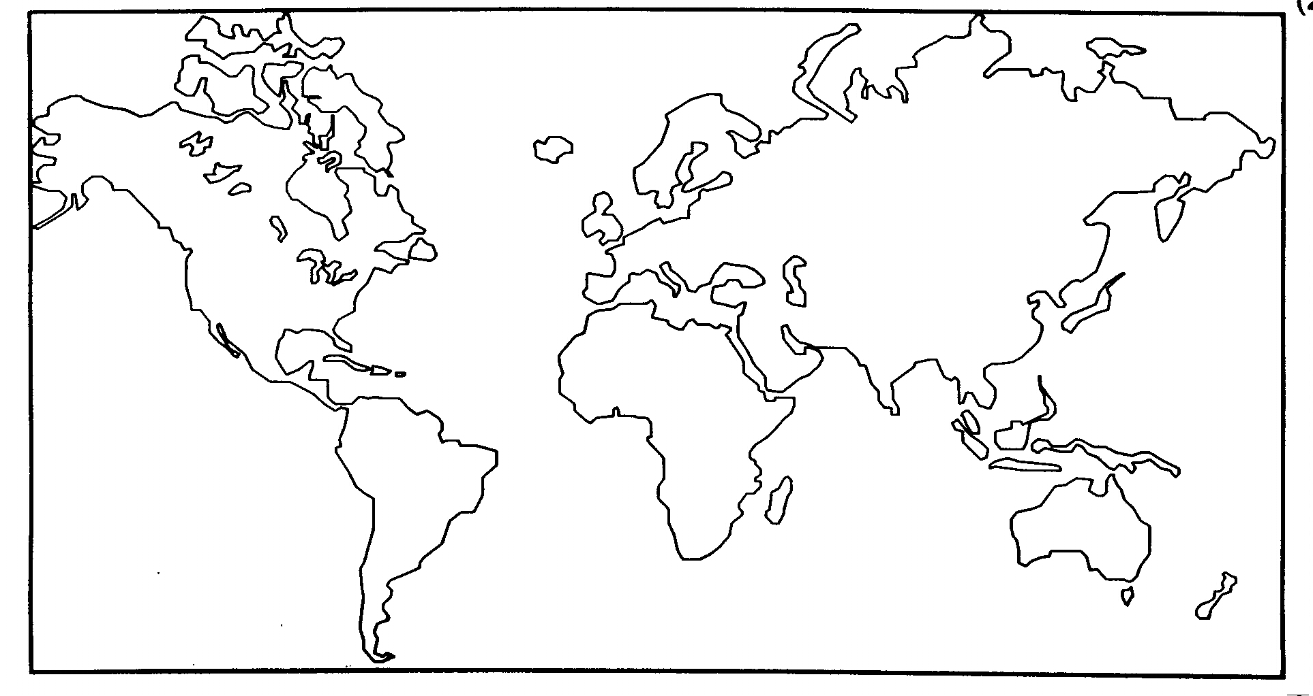

- OUTLINE the climatic characteristics of the Tropical Rainforest biome.
(2 marks)

- SELECT FOUR characteristics from Table 1 below (at least ONE Vegetation and ONE Fauna characteristic). With the aid of diagrams, EXPLAIN how the selected characteristics enable the flora/fauna to survive in the biome. Consider adaptations to climate, soil and other organisms in your answer.
(8 marks)
Flora Characteristics | Fauna Characterstics
- Buttress roots on many large trees  - Ability of some plant species to “climb” or “cling” to other vegetation.  - Evergreen, broadleaved trees.  - Forest floor species able to tolerate low light levels and high humidity.  - Drip-tip leaves  Emergent trees. | - Arboreal (tree dwelling) animals  - Abundance of decomposing micro-organisms on forest floor  - Small mammals with efficient sight living on forest floor.

Table 1: Some characteristics of flora and fauna in the Topical Rainforest Biome.

- With reference to ONE specific case study, DISCUSS the impact of humans on the Tropical Rainforest biome.
(8 marks)

Total = 20 Marks
C6. (a) Examine the following diagram showing the main components of an ecosystem and their
interrelationships. For the Dry Sclerophyllous Forest (Jarrah Forest) discuss the relationship between fauna and flora and any TWO other relationships shown in the diagram.
(15 marks)

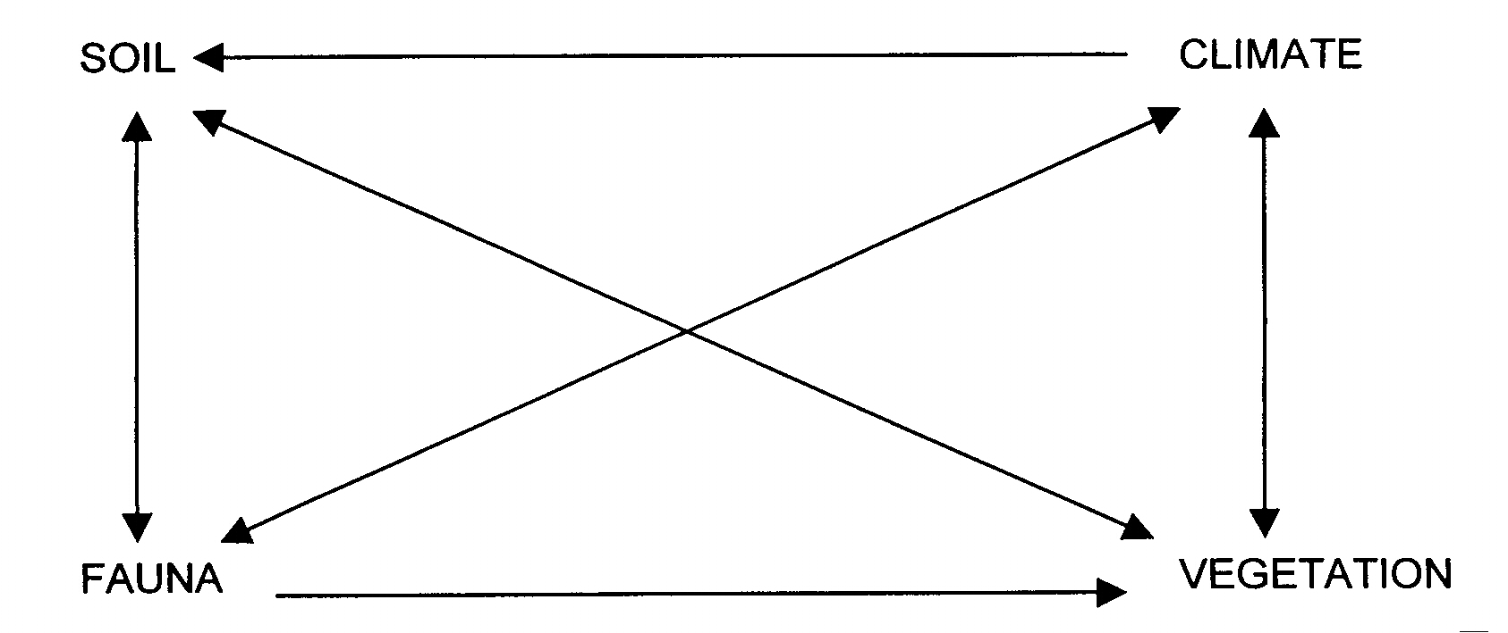

- All Ecosystems aim for a state of equilibrium but man’s interference in the system makes this unattainable. With reference to specific examples discuss this statement.
(5 marks)

Total = 20 Marks
WARNBRO COMMUNITY HIGH SCHOOL

ANSWER SHEET

Year 11 Geography
Semester 2, 2000

Name……………………………………………………….

Question  Number | Answer |  |  |  |  | Question  Number | Answer
1 | A | B | C | D |  | 10 | A | B | C | D
2(i) | A | B | C | D |  | 11 | A | B | C | D
2(ii) |  |  |  |  |  | 12 | A | B | C | D
3 | A | B | C | D |  | 13
4 | A | B | C | D |  | 14 | A | B | C | D
5 | A | B | C | D |  | 15 | A | B | C | D
6 | A | B | C | D |  | 16 | A | B | C | D
7 | A | B | C | D |  | 17 | A | B | C | D
8 | A | B | C | D |  | 18 | A | B | C | D
9 | A | B | C | D |  | 19 | A | B | C | D

2(ii) Show Working Here

